Official league roster - Basketball
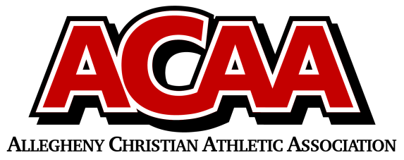

School Name: CACS
Team Colors: Black, White, Red
Overall Wins ___ Losses ____ Ties ___
ACAA Wins ___ Losses ____ Ties ___ OPPONENT: __________________________
Date: _________
Number | Name | Year | Position | Height | Homeschool
10 | Brennan Michael | 12 | G | 5’ 10’’
33 | Vincent Stone | 12 | F | 5’ 10’’
32 | Noah Michael | 11 | G | 5’ 10’’
20 | Eli Mann | 10 | C | 5’ 11”
3 | Stephen Manno | 10 | G | 5’ 7’’
12 | Liam Ramkawsky | 10 | G | 5’ 8’’
2 | Blake McGarry | 9 | F | 5’ 2”
30 | Cameron McTavish | 9 | F | 5’ 3’’
44 | Luke Smeal | 9 | G | 5’ 2”
25 | Michael Tubbs | 8 | G | 5’ 4”
50 | Gideon Korb | 6 | C | 5’ 5”

Head Coach: Chris Michael
Asst. coach: Dan smeal
Asst. coach:

Official ACAA League Team Roster. to be submitted to the scorer’s table before each game.

